**1. JavaScript Customization Task**

**Scenario 1**:

* Implement a client-side customization for the **Contact** entity form:
  + **Functionality**:
    - Make the "Email Address" field mandatory if the "Preferred Method of Contact" is set to "Email."
    - Make the "Phone Number" field mandatory if the "Preferred Method of Contact" is set to "Phone."
    - Ensure at least one of these fields is filled before saving the form.
  + Use the Dynamics 365 JavaScript API to achieve this.
  + Deploy and test the script on the Contact form.

**Scenario 2**:

* Implement client-side customization for the **Opportunity** entity form:
  + **Functionality**:
    - Disable the "Estimated Revenue" field if the "Opportunity Type" is set to "Fixed Price."
    - Automatically calculate and populate "Estimated Revenue" if the "Opportunity Type" is set to "Variable Price" using the formula:
      * Estimated Revenue = (Total Units * Unit Price) - Discount.

**Solution:**

**Scenario 1:**

***Code:***

var Contact = {

MakeFieldsMandatoryBasedOnMethodOfContact: function (executionContext) {

"use strict";

let formContext = executionContext.getFormContext();

let methodOfContactValue = formContext.getAttribute("preferredcontactmethodcode").getValue();

if (methodOfContactValue === 2) {

formContext.getAttribute("emailaddress1").setRequiredLevel("required");

}

else if (methodOfContactValue === 3) {

formContext.getAttribute("telephone1").setRequiredLevel("required");

}

else {

formContext.getAttribute("emailaddress1").setRequiredLevel("none");

formContext.getAttribute("telephone1").setRequiredLevel("none");

}

},

CheckMandatoryFieldsPopulatedOrNot: function (executionContext) {

"use strict";

let formContext = executionContext.getFormContext();

var eventArgs = executionContext.getEventArgs();

let emailAddress = formContext.getAttribute("emailaddress1").getValue();

let businessPhone = formContext.getAttribute("telephone1").getValue();

if (!emailAddress || !businessPhone) {

Xrm.Navigation.openAlertDialog({ text: "Please check phone and email address field before saving." });

eventArgs.preventDefault();

}

}

};

***Events****:*

**MakeFieldsMandatoryBasedOnMethodOfContact** – OnLoad Contact Form, OnChange PreferredContact Field

**CheckMandatoryFieldsPopulatedOrNot** – OnSave of form

Deployment:

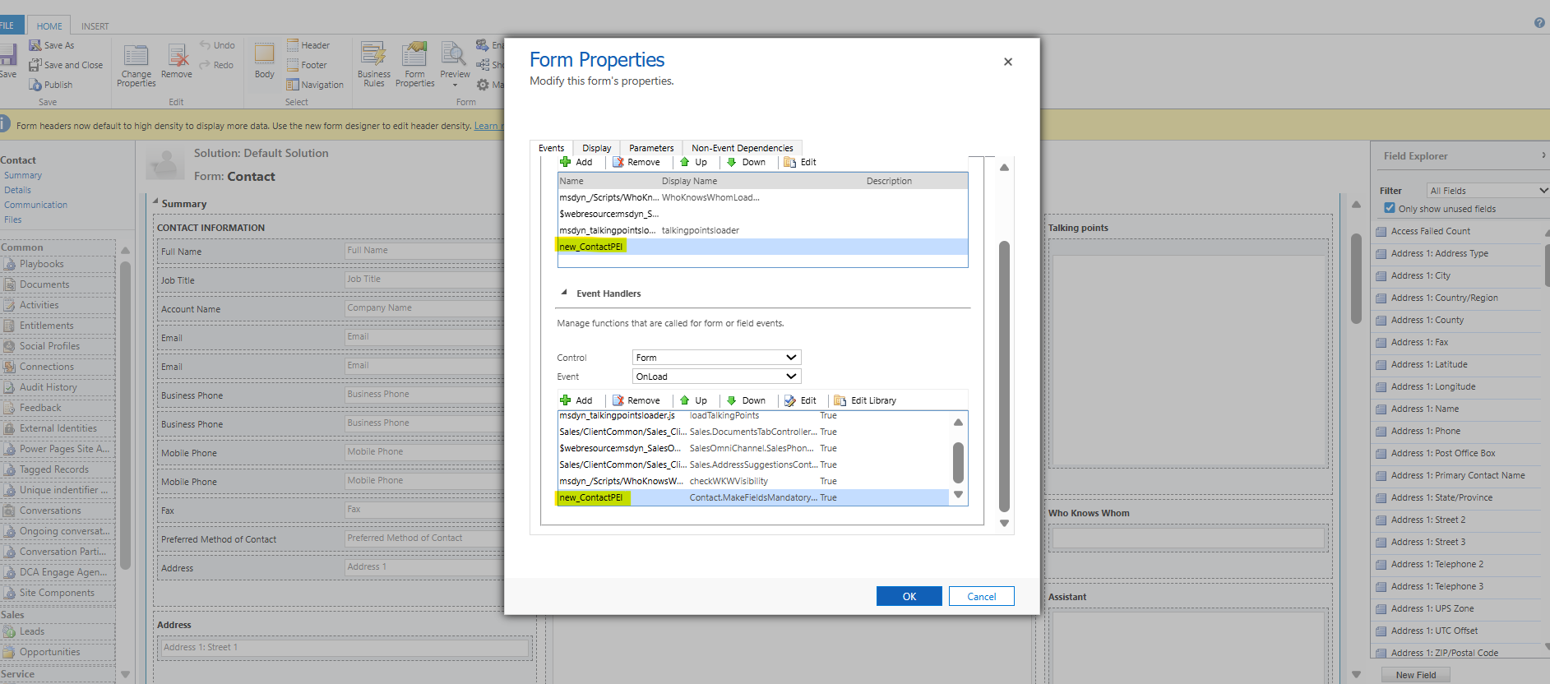

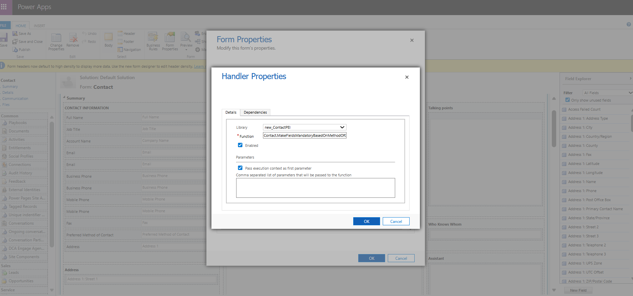

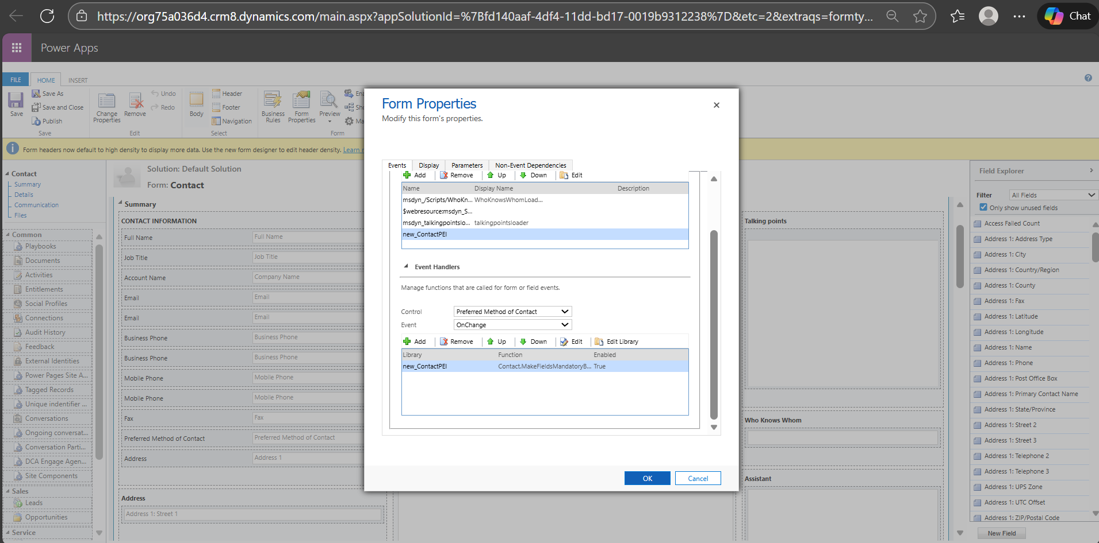

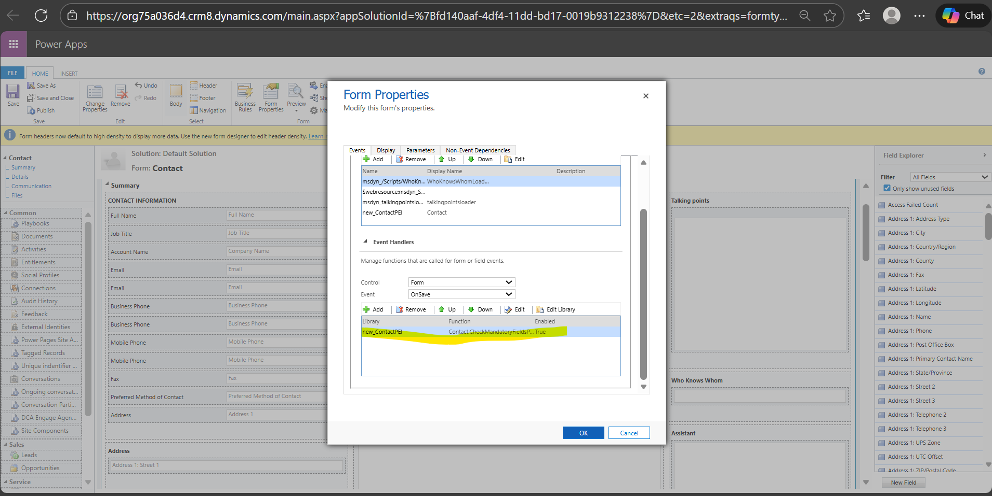

***Unit Test:***

**MakeFieldsMandatoryBasedOnMethodOfContact –**

Check with Preferred method of contacts populated as Phone/Email – Either of the fields should be set as mandatory not both.

Check with Preferred method of contacts populated with other options – Both of the fields should be set as optional

Check with Preferred method of contacts populated as null– Both of the fields should be set as optional

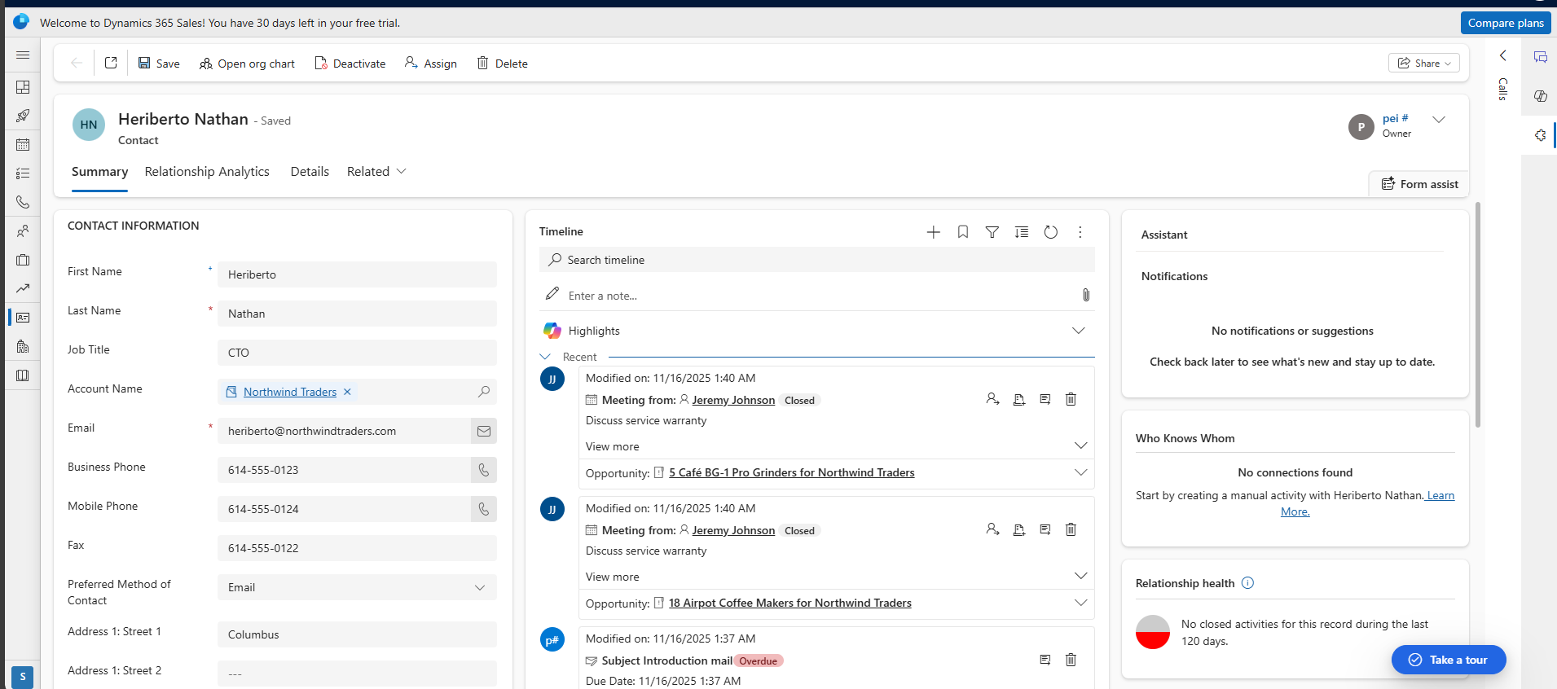

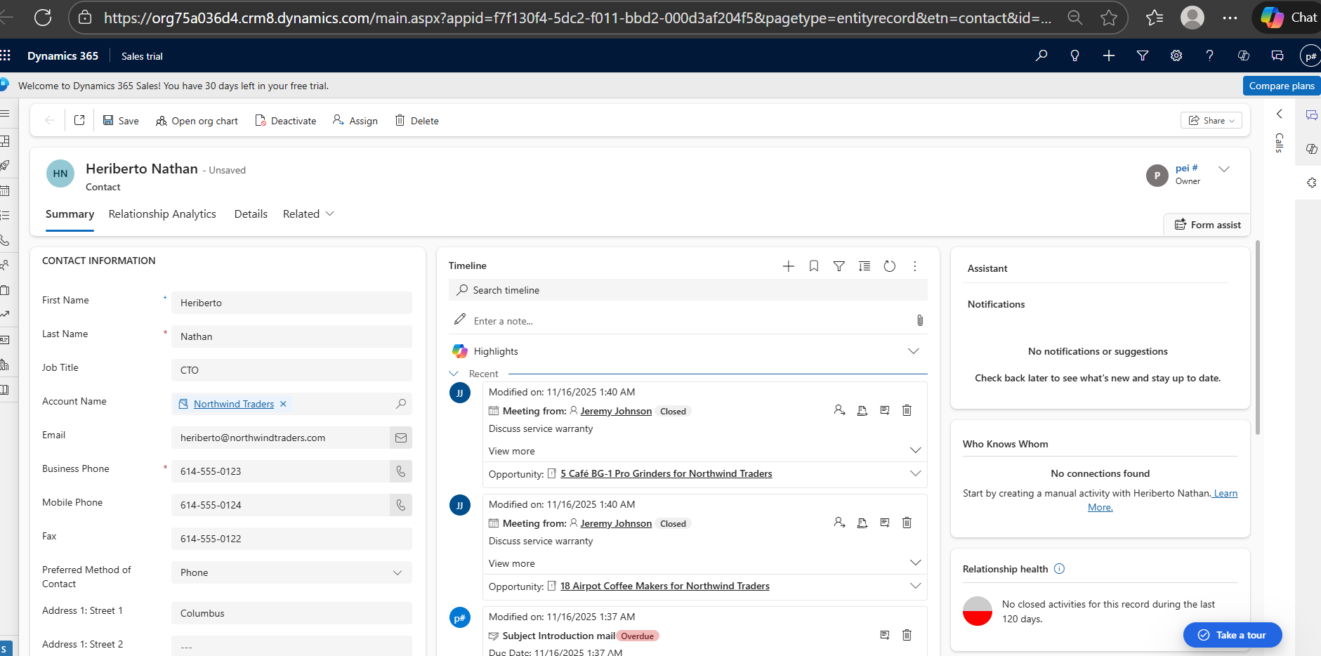

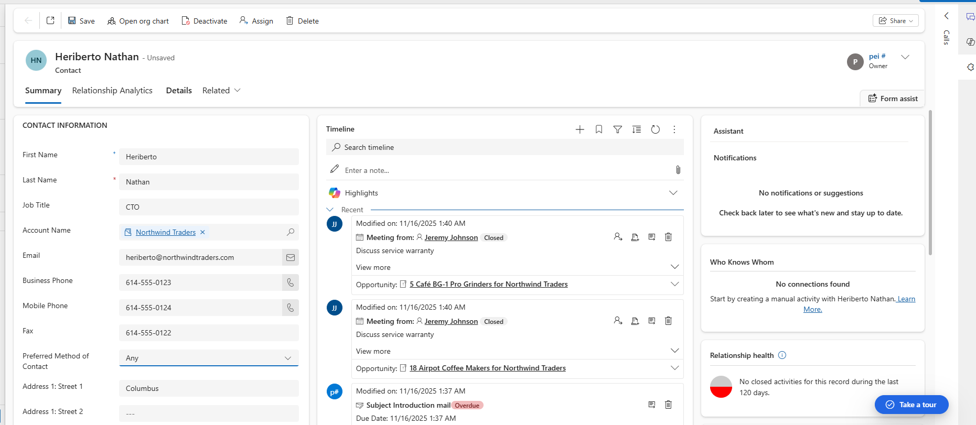

**CheckMandatoryFieldsPopulatedOrNot-**

Check by keeping either of the field as null and save the form it should throw error.

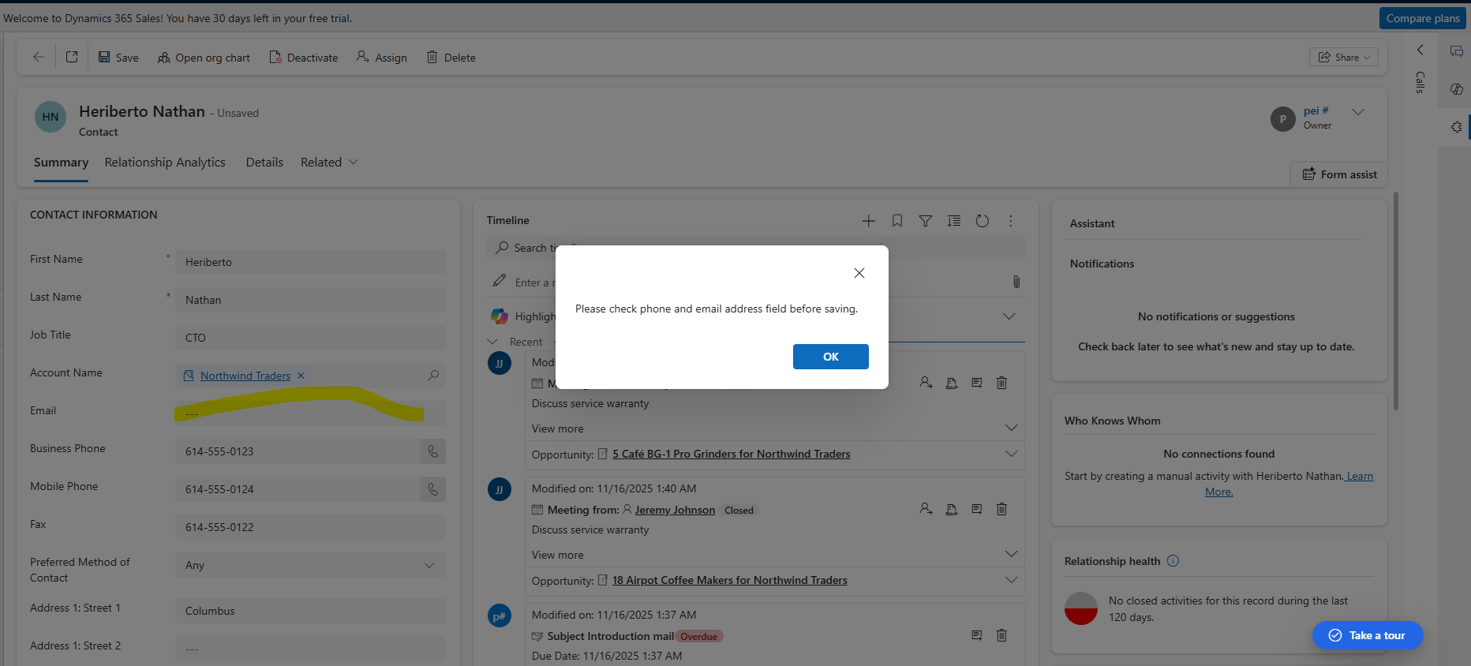

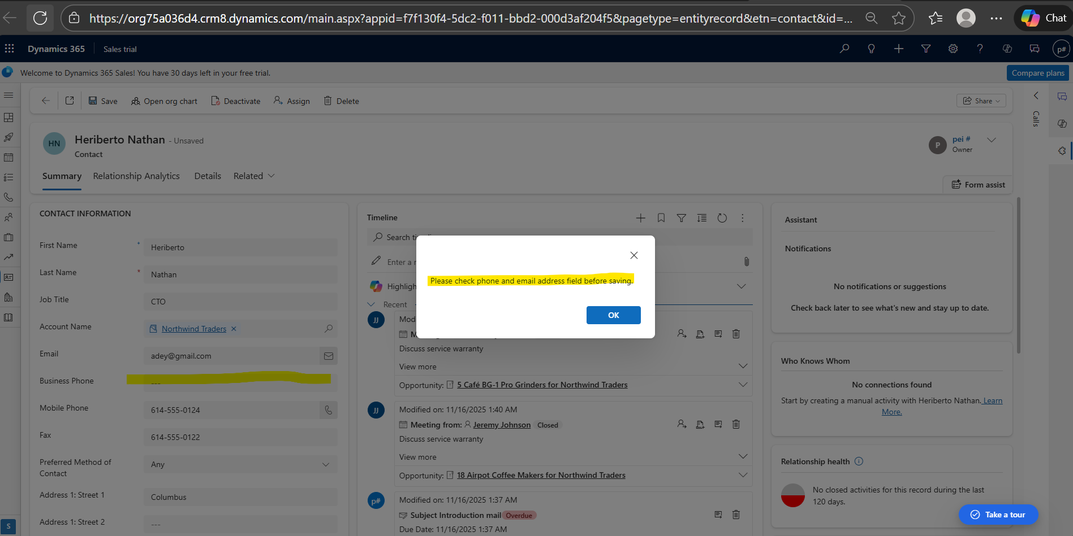

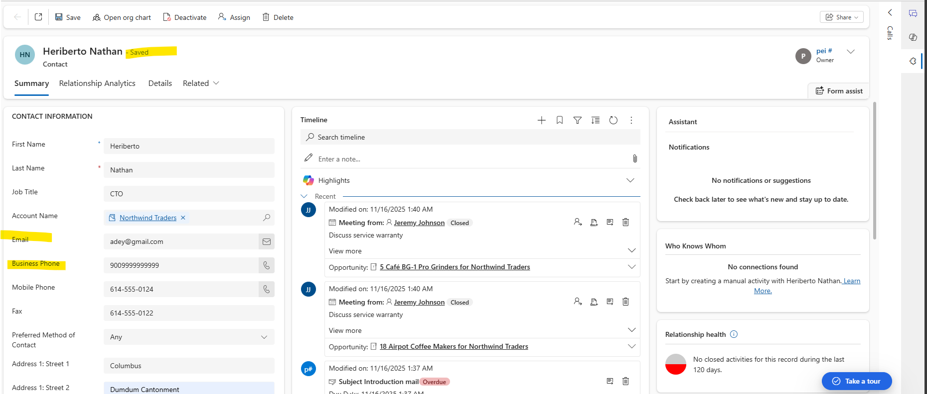

**Scenario 2:**

***Code*:**

var Opportunity = {

EnableDisableEstimatedRevenue: function (executionContext) {

let formContext = executionContext.getFormContext();

let opportunityType = formContext.getAttribute("crac6_opportunitytype").getValue();

if (opportunityType === 1)// Assuming fixed price optionset value is 1

{

formContext.getControl("estimatedvalue").setDisabled(true);

}

else {

formContext.getControl("estimatedvalue").setDisabled(false);

}

},

SetEstimatedRevenue: function (executionContext) {

let formContext = executionContext.getFormContext();

let price = 0;

let opportunityType = formContext.getAttribute("crac6_opportunitytype").getValue();

let estValue = formContext.getAttribute("estimatedvalue").getValue();

if (opportunityType === 2)// Assuming variable price optionset is 2

{

var fetchXml = [

"<fetch>",

" <entity name='opportunityproduct'>",

" <attribute name='opportunityproductid' />",

" <attribute name='quantity' />",

" <attribute name='priceperunit' />",

" <attribute name='manualdiscountamount' />",

" <filter type='and'>",

" <condition attribute='opportunityid' operator='eq' value='", formContext.data.entity.getId(), "' />",

" </filter>",

" </entity>",

"</fetch>"

].join("");

var fetchXmlEncoded = "?fetchXml=" + encodeURIComponent(fetchXml);

Xrm.WebApi.retrieveMultipleRecords("opportunityproduct", fetchXmlEncoded).then(

function success(result) {

if (result.entities.length > 0) {

result.entities.forEach(function (opportunityProduct) {

price = price + ((opportunityProduct.quantity * opportunityProduct.priceperunit) - opportunityProduct.manualdiscountamount)

});

if (estValue !== price) {

formContext.getAttribute("estimatedvalue").setValue(price);

}

} else {

console.log("No opportunity products found for this opportunity.");

}

},

function error(e) {

console.error("Error retrieving opportunity products:", e);

}

);

}

}

};

**Deployment**:

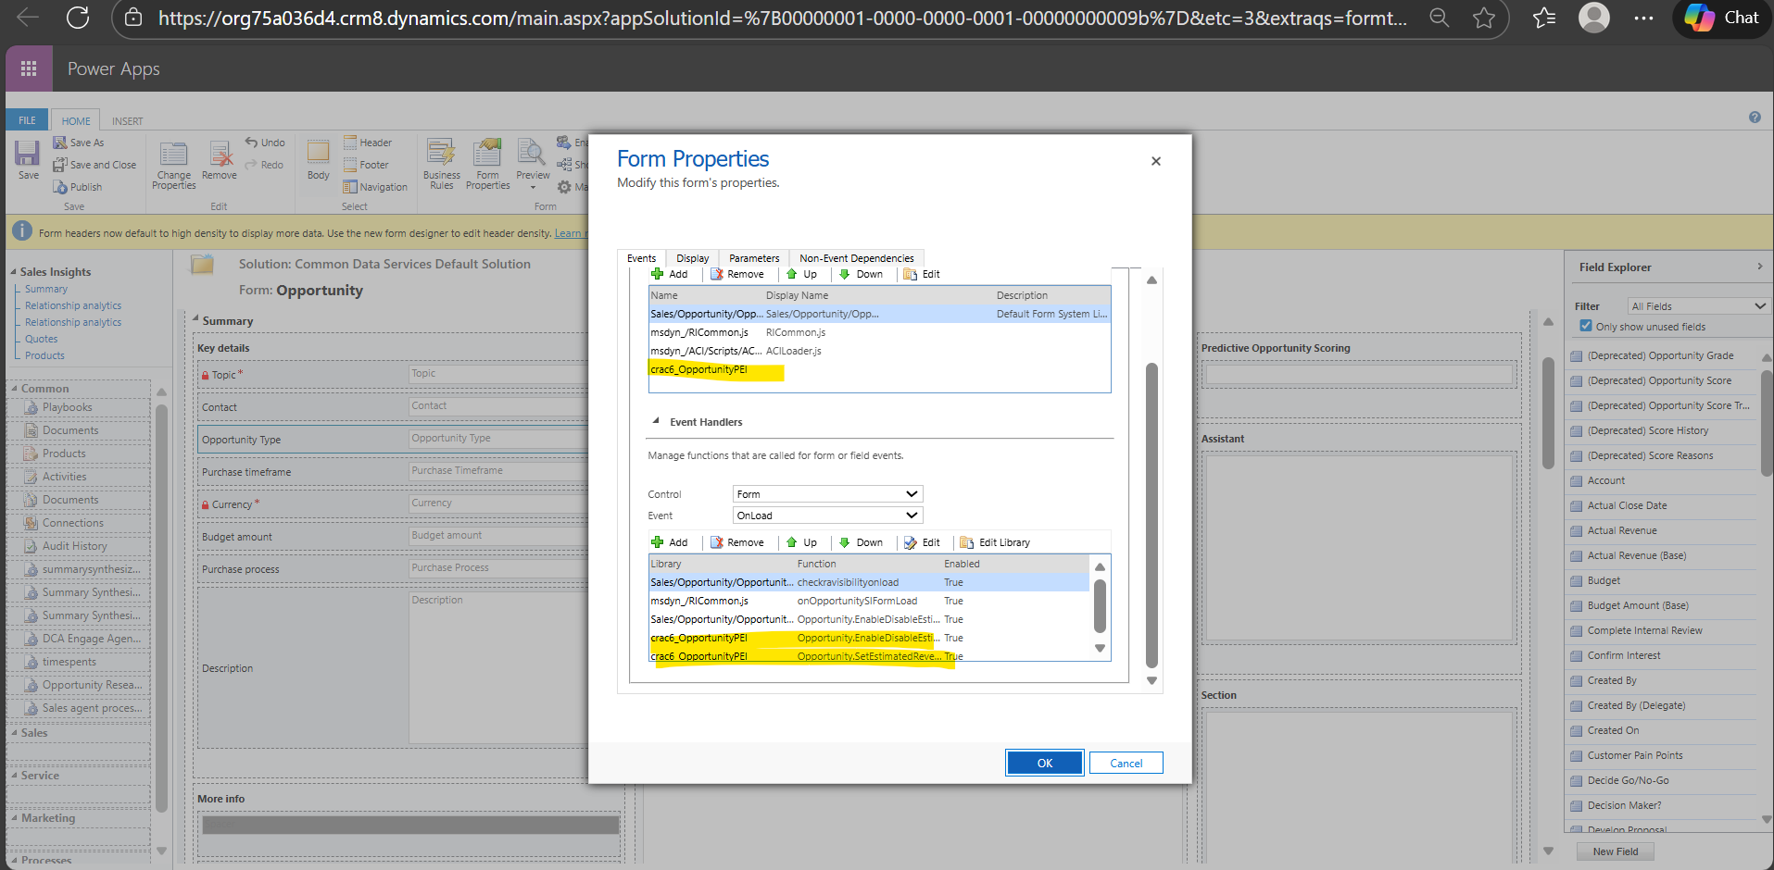

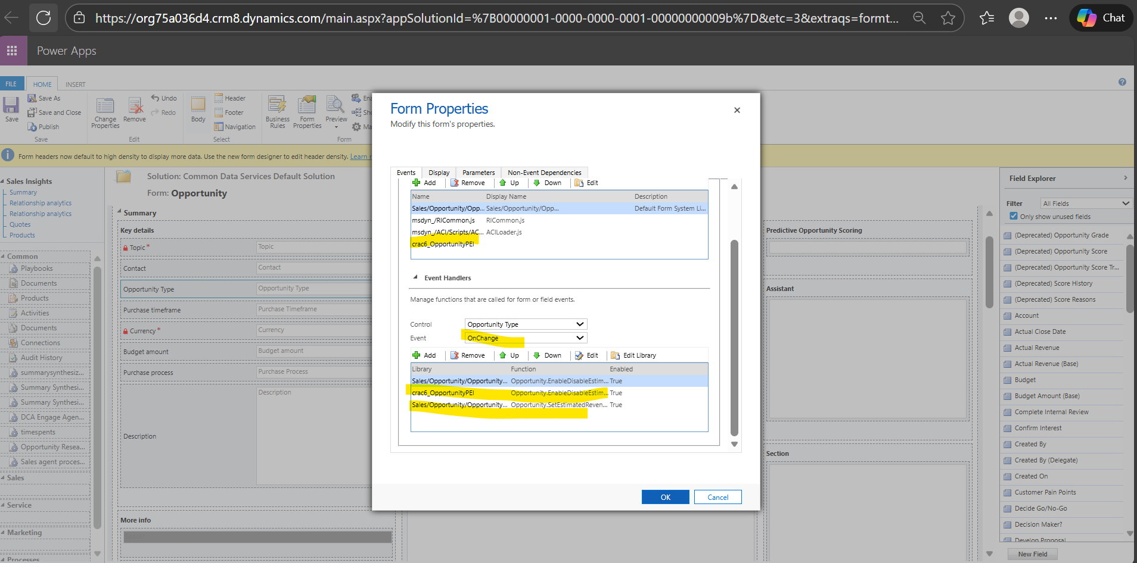

***Unit Test****:*

EnableDisableEstimatedRevenue-

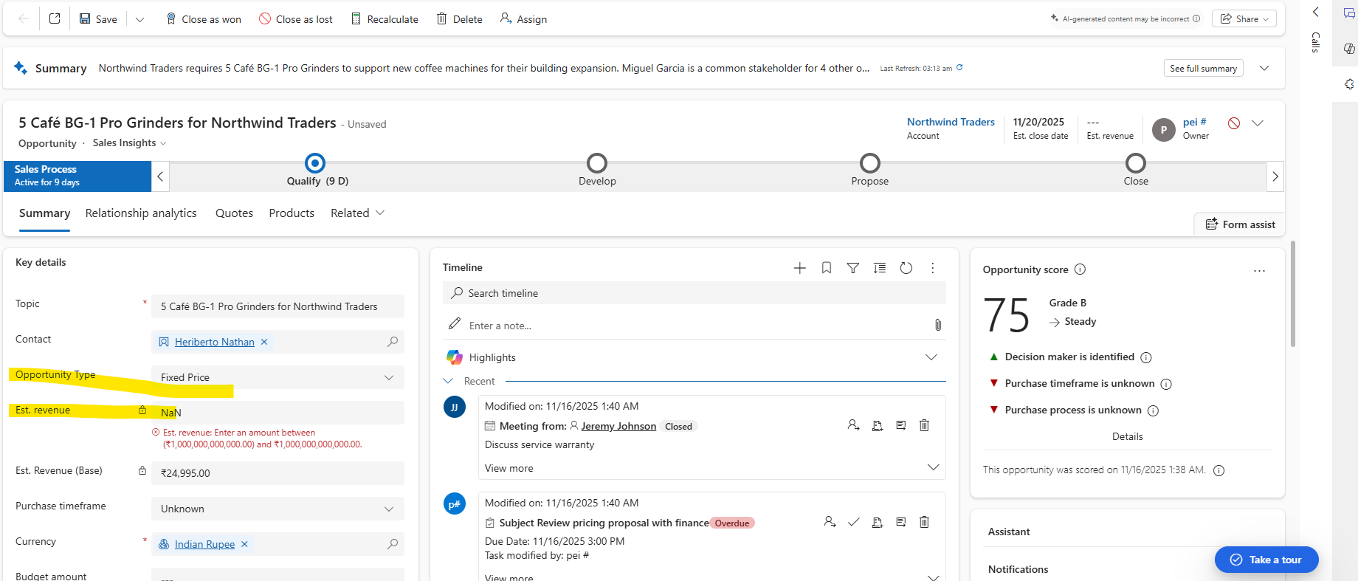

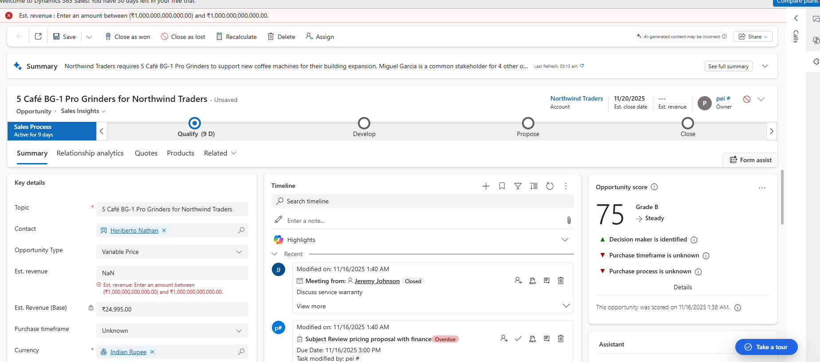

Keep the Opportunity type as null the estimated value should be enabled

Keep the opportunity type as fixed price the estimated value should be disabled

Keep the opportunity type to some other value apart from fixed value the estimated value should be enabled

SetEstimatedRevenue-

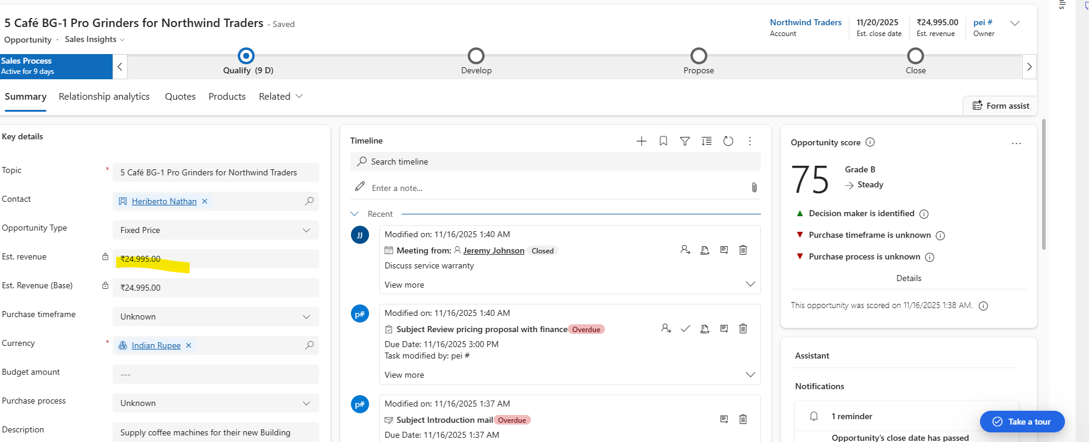

Keep the opportunity type as null or other value apart from variable value the estimated revenue should not be calculated

Keep the opportunity type as variable value and create opportunity line with quantity and price per unit the estimated revenue should be calculated

Keep the opportunity type as variable value and create opportunity line with 0 quantity or 0 price per unit the estimated revenue should be updated as 0.

***Deployment Steps:***

Go to the entity form>Form properties>Add Form Library 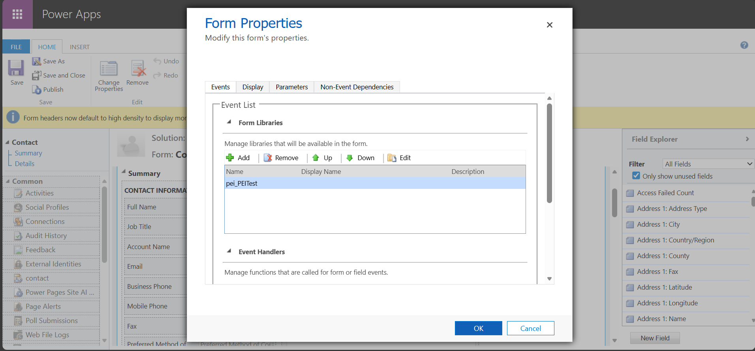

Add Event Handler with Control as Form/Specific Field and event as OnLoad/OnSave

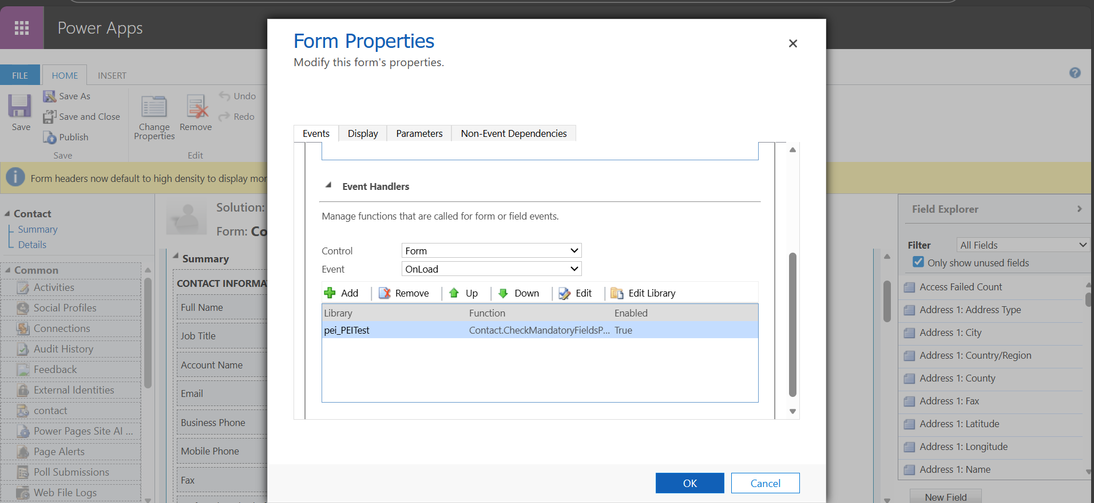

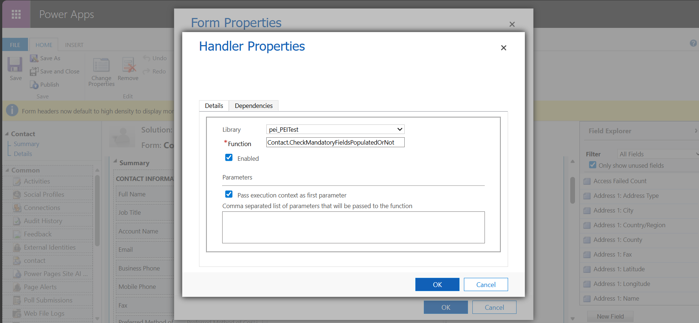

***Identify the issues with this approach***

Client side validations or calculations are not full proof specially when creating records from backend instead the validation logics should be moved to plugin.

Field enable/disable or mandatory/non mandatory can be achieved through Business Rule instead of js promoting more low code/no code.

**2. Plugin Development Task**

**Scenario 1**:

* Develop a plugin for the **Contact** entity:
  + Prevent the creation of duplicate Contacts with the same email address.
  + Display an error message: *"A contact with this email address already exists."*
  + Ensure the plugin is efficient and scalable for large datasets.

**Scenario 2**:

* Develop a plugin for the **Account** entity:
  + On Account creation, automatically create a child Contact with:
    - First Name: *Default*.
    - Last Name: *Account Name*.
  + Log a message in the plugin trace log after successful execution.

**Scenario 1**:

***Code:***

using Microsoft.Xrm.Sdk;

using Microsoft.Xrm.Sdk.Query;

using System;

namespace Contact

{

public class ContactDuplicateEmailCheck : IPlugin

{

public void Execute(IServiceProvider serviceProvider)

{

ITracingService tracingService = (ITracingService)serviceProvider.GetService(typeof(ITracingService));

IPluginExecutionContext context = (IPluginExecutionContext)serviceProvider.GetService(typeof(IPluginExecutionContext));

IOrganizationServiceFactory serviceFactory = (IOrganizationServiceFactory)serviceProvider.GetService(typeof(IOrganizationServiceFactory));

IOrganizationService service = serviceFactory.CreateOrganizationService(context.UserId);

if (context.MessageName.ToLower() == "create" && context.PrimaryEntityName.ToLower() == "contact")

{

if (context.InputParameters.Contains("Target") && context.InputParameters["Target"] is Entity targetEntity)

{

if (targetEntity.LogicalName == "contact")

{

if (targetEntity.Contains("emailaddress1") && targetEntity["emailaddress1"] != null)

{

string emailAddress = targetEntity["emailaddress1"].ToString();

QueryExpression query = new QueryExpression("contact")

{

ColumnSet = new ColumnSet("contactid"),

Criteria = new FilterExpression(LogicalOperator.And)

{

Conditions =

{

new ConditionExpression("emailaddress1", ConditionOperator.Equal, emailAddress)

}

}

};

EntityCollection existingContacts = service.RetrieveMultiple(query);

if (existingContacts.Entities.Count > 0)

{

throw new InvalidPluginExecutionException("A contact with this email address already exists.");

}

}

}

}

}

}

}

}

***Register:***

Sign the assembly with a signing key

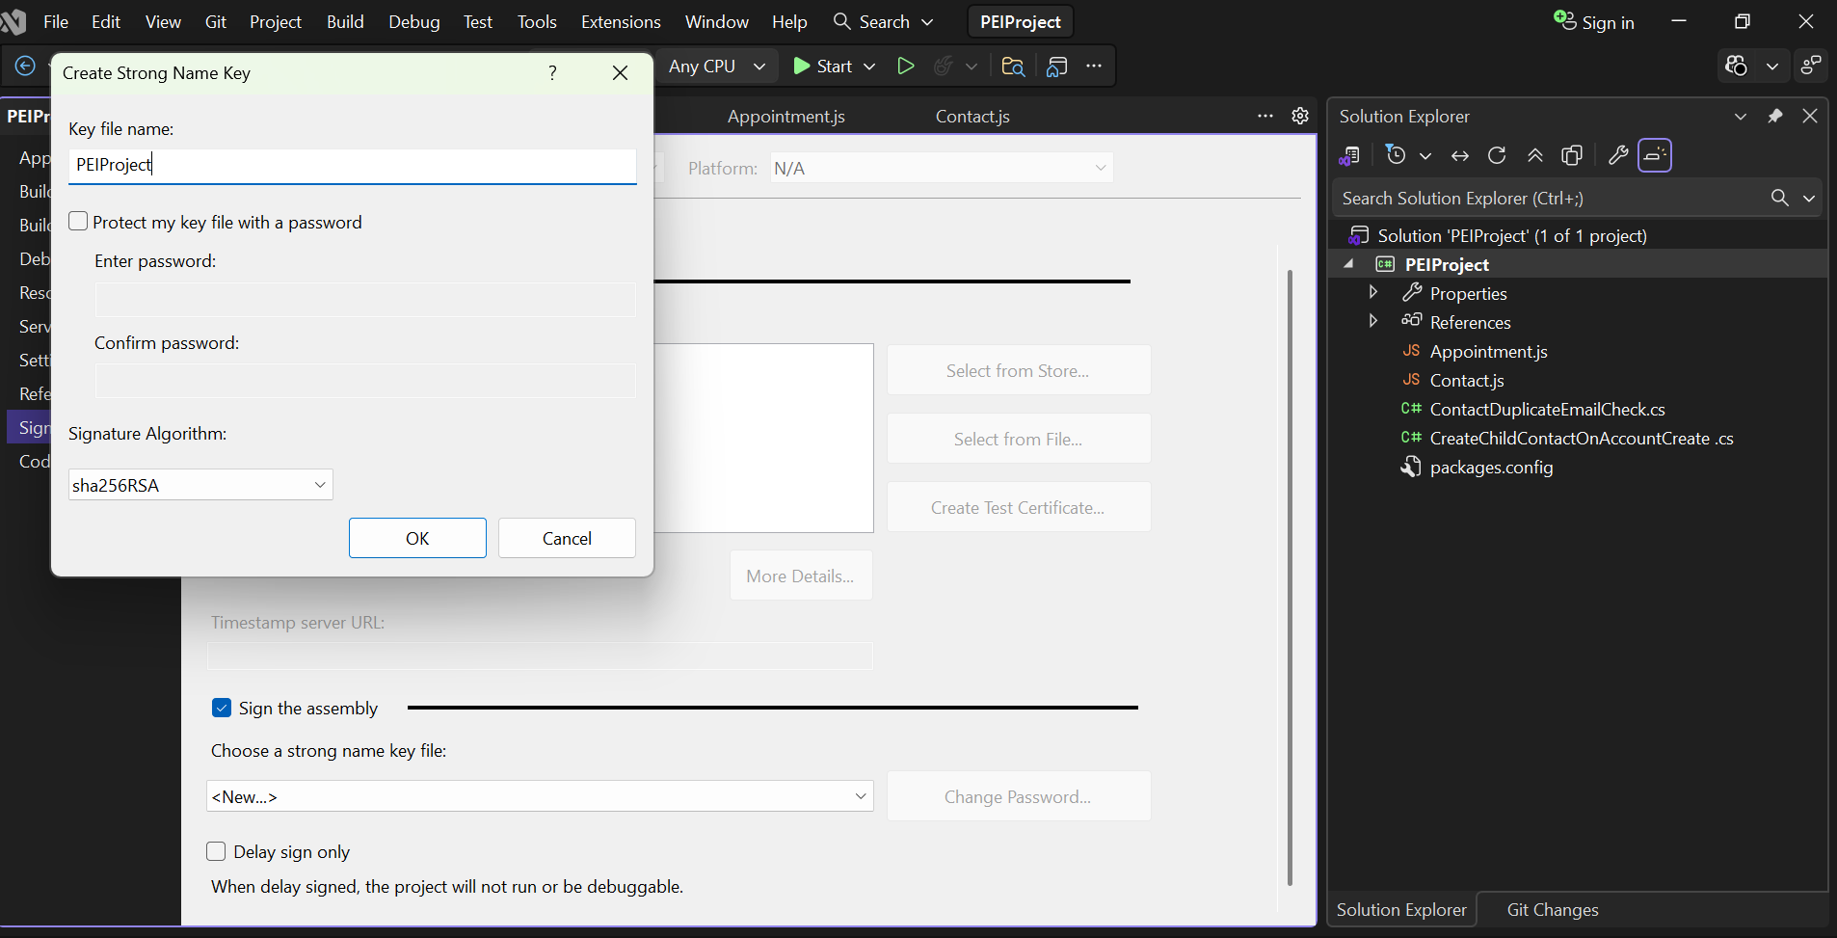

Register the assembly with the plugin

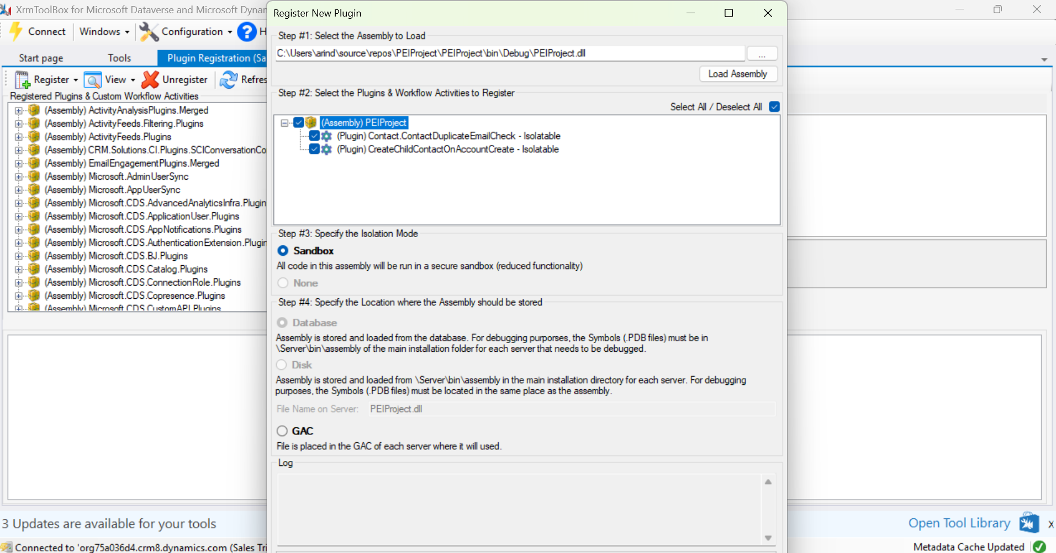

Register a new step for the plugin:

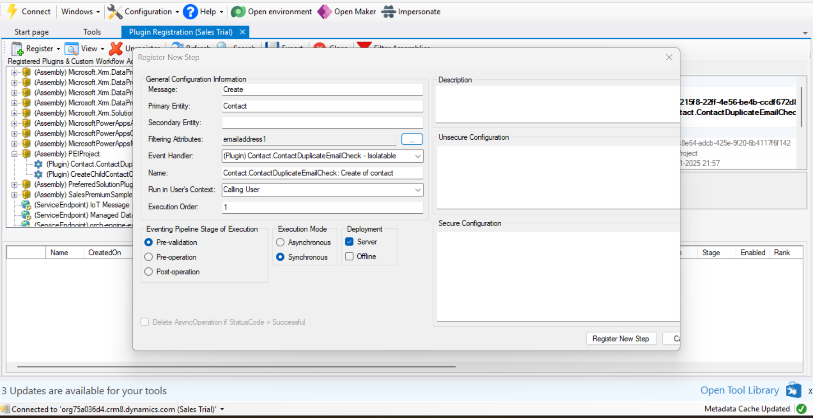

* **Message:** Create
* **Primary Entity:** Contact
* **FilteringAttribute:** emailaddress1
* **Event Pipeline Stage:** PreValidation
* **Execution Mode:** Synchronous

**Tests:**

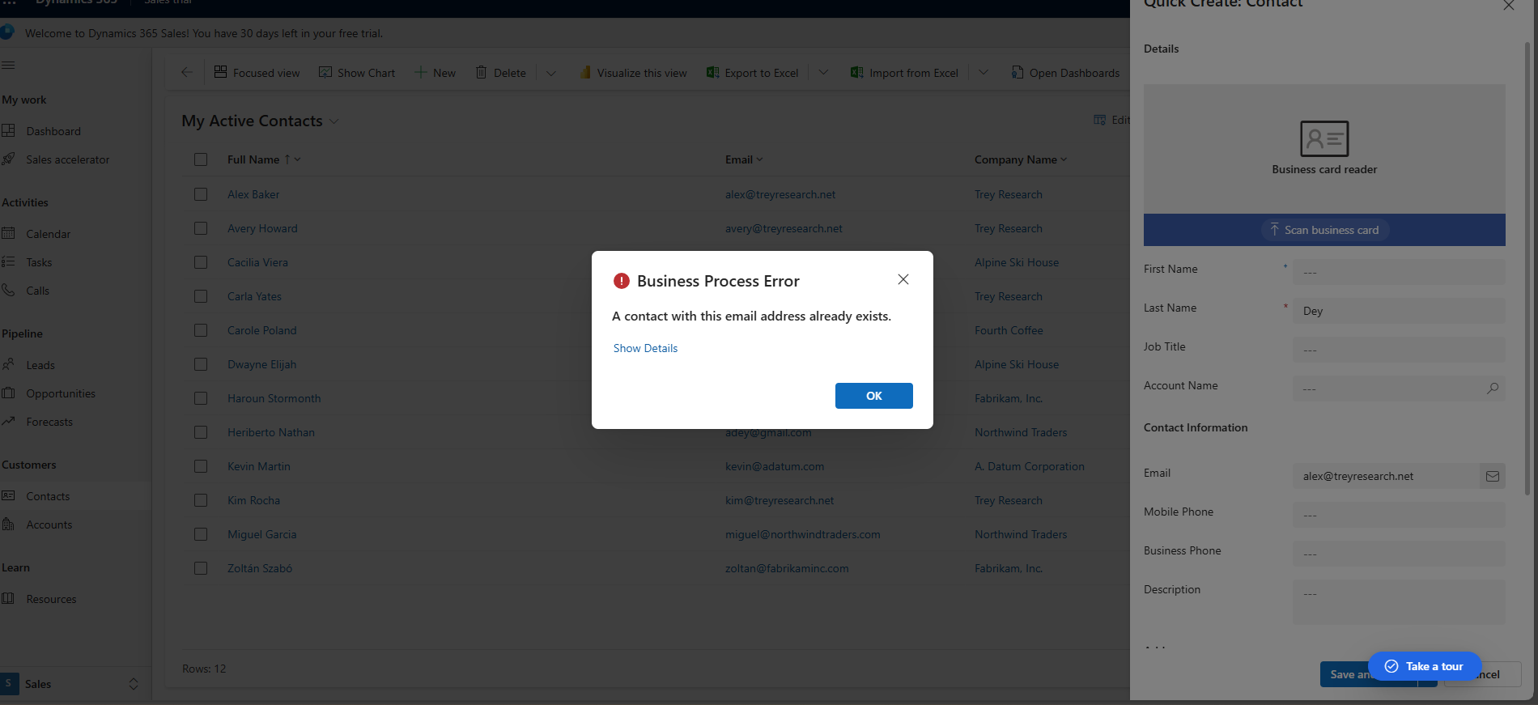

***Unit test:***

[TestMethod]

public void CreateContact_WithDuplicateEmail_ThrowsException()

{

var context = new XrmFakedContext();

var plugin = new ContactDuplicateEmailCheck();

// Create an existing contact with an email

var existingContact = new Entity("contact")

{

Id = Guid.NewGuid(),

["emailaddress1"] = "test@example.com"

};

context.Initialize(new[] { existingContact });

var newContact = new Entity("contact")

{

["emailaddress1"] = "test@example.com"

};

// Act & Assert

var ex = Assert.ThrowsException<InvalidPluginExecutionException>(() =>

{

context.ExecutePluginWithTarget(plugin, newContact, "Create");

});

Assert.AreEqual("A contact with this email address already exists.", ex.Message);

}

[TestMethod]

public void CreateContact_WithUniqueEmail_Succeeds()

{

var context = new XrmFakedContext();

var plugin = new ContactDuplicateEmailCheck();

var existingContact = new Entity("contact")

{

Id = Guid.NewGuid(),

["emailaddress1"] = "aa@example.com"

};

context.Initialize(new[] { existingContact });

// Create a new contact with a unique email

var newContact = new Entity("contact")

{

["emailaddress1"] = "bb@example.com"

};

context.ExecutePluginWithTarget(plugin, newContact, "Create");

Assert.Equals(context.GetOrganizationService().RetrieveMultiple(new QueryExpression("contact")).Entities.Count,2);

}

**Scenario 2:**

***Code:***

using Microsoft.Xrm.Sdk;  
using Microsoft.Xrm.Sdk.Query;  
using System;  
  
public class CreateChildContactOnAccountCreate : IPlugin  
{  
 public void Execute(IServiceProvider serviceProvider)  
 {  
 ITracingService tracingService = (ITracingService)serviceProvider.GetService(typeof(ITracingService));  
 IPluginExecutionContext context = (IPluginExecutionContext)serviceProvider.GetService(typeof(IPluginExecutionContext));  
 IOrganizationServiceFactory serviceFactory = (IOrganizationServiceFactory)serviceProvider.GetService(typeof(IOrganizationServiceFactory));  
 IOrganizationService service = serviceFactory.CreateOrganizationService(context.UserId);  
  
 if (context.InputParameters.Contains("Target") && context.InputParameters["Target"] is Entity account && context.MessageName == "Create")  
 {  
 try  
 {  
 string accountName = account.GetAttributeValue<string>("name");  
  
 Entity contact = new Entity("contact");  
 contact["firstname"] = "Default";  
 contact["lastname"] = accountName;  
 contact["parentcustomerid"] = new EntityReference("account", account.Id);  
  
 service.Create(contact);  
  
 tracingService.Trace("CreateChildContactOnAccountCreate: Successfully created child Contact for Account '{0}'", accountName);  
 }  
 catch (Exception ex)  
 {  
 tracingService.Trace("CreateChildContactOnAccountCreate: An error occurred: {0}", ex.ToString());  
 throw new InvalidPluginExecutionException("An error occurred in the CreateChildContactOnAccountCreate plugin.", ex);  
 }  
 }  
 }  
}

***Register*:**

Sign the assembly with a signing key



Register the assembly with the plugin



Register a new step for the plugin:

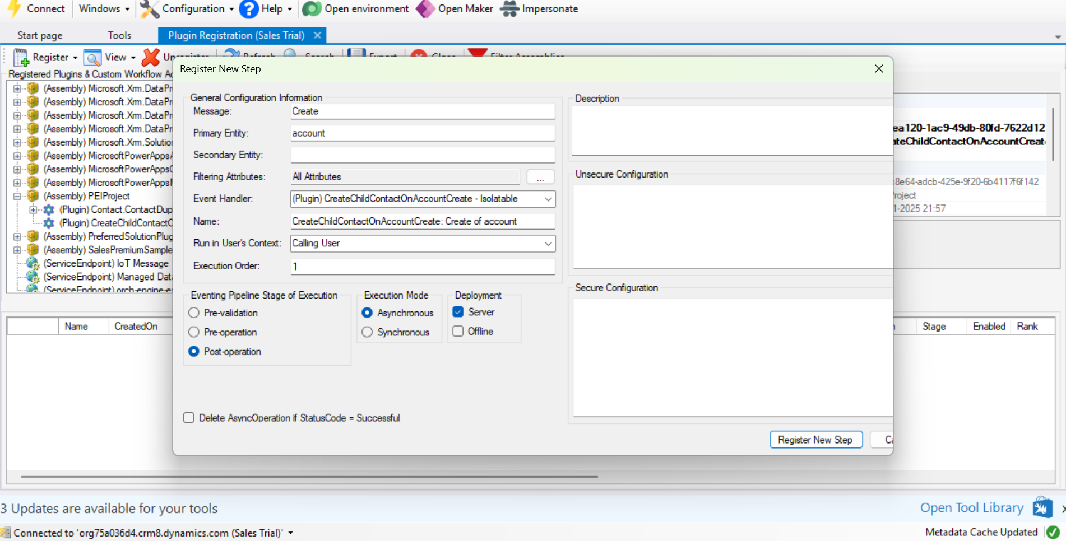

* **Message:** Create
* **Primary Entity:** Account
* **Event Pipeline Stage:** PostOperation
* **Execution Mode:** Asynchronous

**Test:**

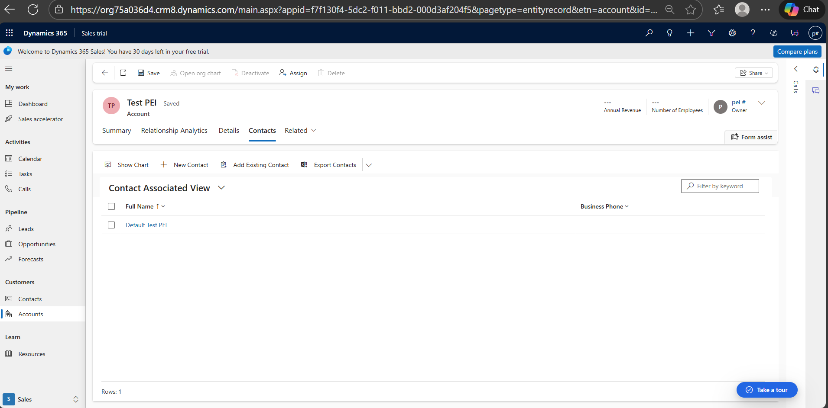

***Unit test case:***

using FakeXrmEasy;

using Microsoft.VisualStudio.TestTools.UnitTesting;

using Microsoft.Xrm.Sdk;

using Microsoft.Xrm.Sdk.Query;

using System;

namespace UnitTestProject1

{

[TestClass]

public class AccountCreationContactPluginTests

{

[TestMethod]

public void OnAccountCreate_ShouldCreateChildContact()

{

// Arrange

var fakedContext = new XrmFakedContext();

var fakedTracingService = fakedContext.GetFakeTracingService();

var account = new Entity("account")

{

Id = Guid.NewGuid(),

["name"] = "Test Account"

};

var pluginContext = new XrmFakedPluginExecutionContext

{

MessageName = "Create",

Stage = 40,

InputParameters = new ParameterCollection { { "Target", account } },

PrimaryEntityName = "account",

PrimaryEntityId = account.Id

};

// Act

fakedContext.ExecutePluginWith<ContactDuplicateEmailCheck>(pluginContext);

// Assert

var createdContacts = fakedContext.GetOrganizationService().RetrieveMultiple(new QueryExpression("contact"));

Assert.AreEqual(1, createdContacts.Entities.Count, "A child contact should be created.");

var createdContact = createdContacts.Entities[0];

Assert.AreEqual("Default", createdContact["firstname"], "Contact First Name should be 'Default'.");

}

}

}

***CI/CD Pipeline:***

Install the NuGet tool installer

Restore the NuGet packages of the solution

Build the solution and the plugin project with VSBuild generate the .nupkg file

Copy the contents to artifacts folder and publish it

Install Power Platform CLI tools in Azure Devops

Create a connection to the environment using credentials: [pac auth create -u $(envUrl) -n Dev -un $(envUsername) -p $(envPassword)](https://learn.microsoft.com/en-us/power-platform/developer/cli/reference/auth?WT.mc_id=DX-MVP-5004571)

Run [pac plugin push -id {pluginpackageid} -pf $(Build.ArtifactStagingDirectory)\Plugins\Plugins.1.0.0.nupkg](https://learn.microsoft.com/en-us/power-platform/developer/cli/reference/plugin?WT.mc_id=DX-MVP-5004571)

Alternatively we can pack the plugin dll into a solution and deploy the solution using Power Platform Tools connector in azure devops

**3. Use Workflow (or Power Automate)**

**Scenario**:

* Create a flow to calculate the total invoice amount, including tax which triggers when an invoice is created.
  + Inputs: InvoiceAmount (decimal), TaxRate (decimal).
  + Output: TotalAmount = InvoiceAmount + (InvoiceAmount * TaxRate).
* Create a flow to calculate the total invoice amount, including tax which triggers when an invoice is created.
  + Inputs: InvoiceAmount (decimal), TaxRate (decimal).
  + Output: TotalAmount = InvoiceAmount + (InvoiceAmount * TaxRate).

**Power automate flow:**

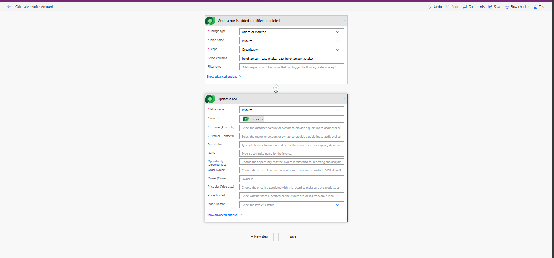

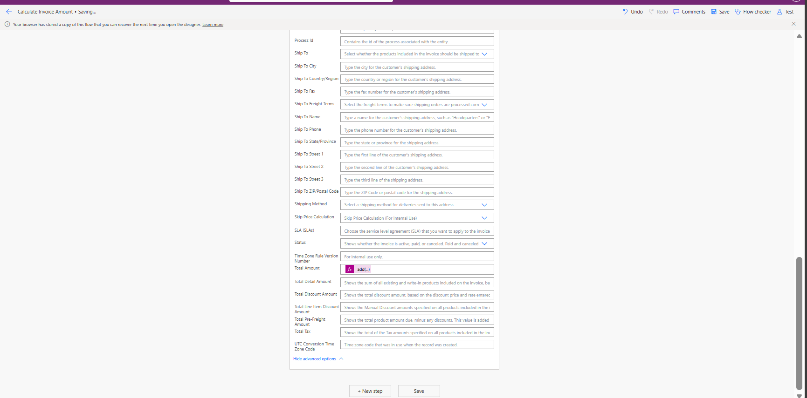

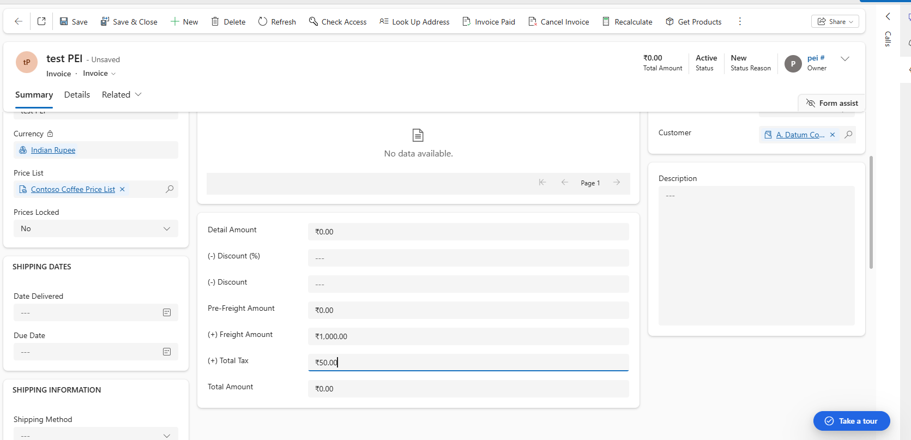

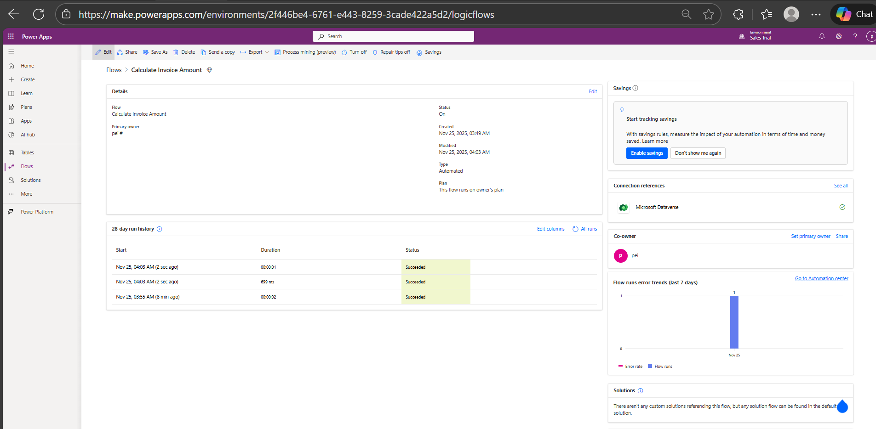

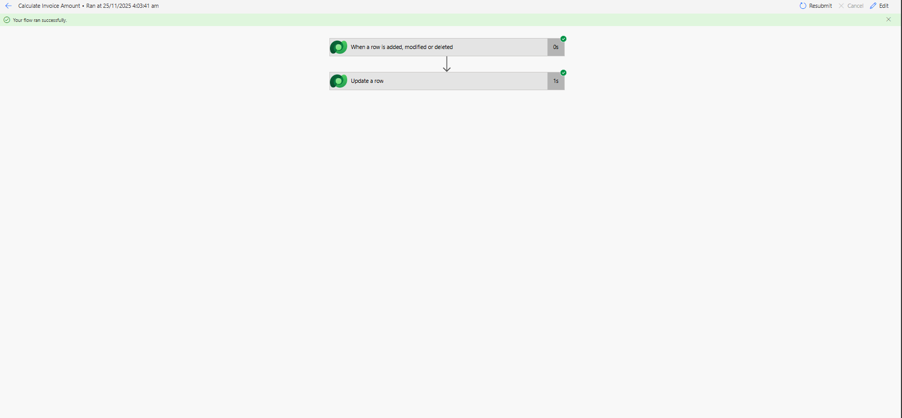

**4. Integration Task**

**Scenario**:

* Integrate Dynamics 365 CRM with a mock external API to send customer order details upon Order creation.
  + **Requirements**:
    - Develop a console application or Azure Function in C#.
    - Retrieve newly created Order records.
    - Send details (e.g., Customer Name, Order Total, Order Date) to a mock REST API.
    - Log success or failure responses.

***Code:***

using Microsoft.AspNetCore.Http;

using Microsoft.AspNetCore.Mvc;

using Microsoft.Azure.Functions.Worker;

using Microsoft.Extensions.Logging;

using System.Text;

using System.Text.Json.Nodes;

namespace FunctionApp1

{

public class Function1

{

private readonly ILogger<Function1> _logger;

public Function1(ILogger<Function1> logger)

{

_logger = logger;

}

[Function("Function1")]

public void Run([HttpTrigger(AuthorizationLevel.Function, "get", "post")] HttpRequest req)

{

String jsonContext = new StreamReader(req.Body).ReadToEndAsync().Result;

jsonContext = FormatJson(jsonContext);

_logger.LogInformation("Read context: " + jsonContext);

Microsoft.Xrm.Sdk.RemoteExecutionContext context = DeserializeJsonString<Microsoft.Xrm.Sdk.RemoteExecutionContext>(jsonContext);

Microsoft.Xrm.Sdk.Entity targetEntity = (Microsoft.Xrm.Sdk.Entity)context.InputParameters["Target"];

string createdOn = targetEntity.GetAttributeValue<string>("modifiedon");

string name = targetEntity.GetAttributeValue<string>("accountid");

string orderid = targetEntity.GetAttributeValue<string>("modifiedby");

JsonObject result = new JsonObject()

{

{"Created On", createdOn},

{"Name", name},

{"Order Id", orderid}

};

CallExternalApi("", "", result.ToString());

}

/// <summary>

/// Function to deserialize JSON string using DataContractJsonSerializer

/// </summary>

/// <typeparam name="RemoteContextType">RemoteContextType Generic Type</typeparam>

/// <param name="jsonString">string jsonString</param>

/// <returns>Generic RemoteContextType object</returns>

public static RemoteContextType DeserializeJsonString<RemoteContextType>(string jsonString)

{

//create an instance of generic type object

RemoteContextType obj = Activator.CreateInstance<RemoteContextType>();

MemoryStream ms = new MemoryStream(Encoding.Unicode.GetBytes(jsonString));

System.Runtime.Serialization.Json.DataContractJsonSerializer serializer = new System.Runtime.Serialization.Json.DataContractJsonSerializer(obj.GetType());

obj = (RemoteContextType)serializer.ReadObject(ms);

ms.Close();

return obj;

}

/// <summary>

/// Function to convert the unformatted Json string to formatted Json string

/// </summary>

/// <param name="unformattedJson"></param>

/// <returns>string formattedJsonString</returns>

public static string FormatJson(string unformattedJson)

{

string formattedJson = string.Empty;

try

{

formattedJson = unformattedJson.Trim('"');

formattedJson = System.Text.RegularExpressions.Regex.Unescape(formattedJson);

}

catch (Exception ex)

{

throw new Exception(ex.Message);

}

return formattedJson;

}

public async Task CallExternalApi(string accessToken, string apiUrl, string requestBody)

{

using (HttpClient client = new HttpClient())

{

client.DefaultRequestHeaders.Authorization = new System.Net.Http.Headers.AuthenticationHeaderValue("Bearer", accessToken);

StringContent content = new StringContent(requestBody, Encoding.UTF8, "application/json");

HttpResponseMessage response = await client.PostAsync(apiUrl, content);

response.EnsureSuccessStatusCode(); // Throws an exception if not successful

string responseBody = await response.Content.ReadAsStringAsync();

// Process responseBody

}

}

}

}

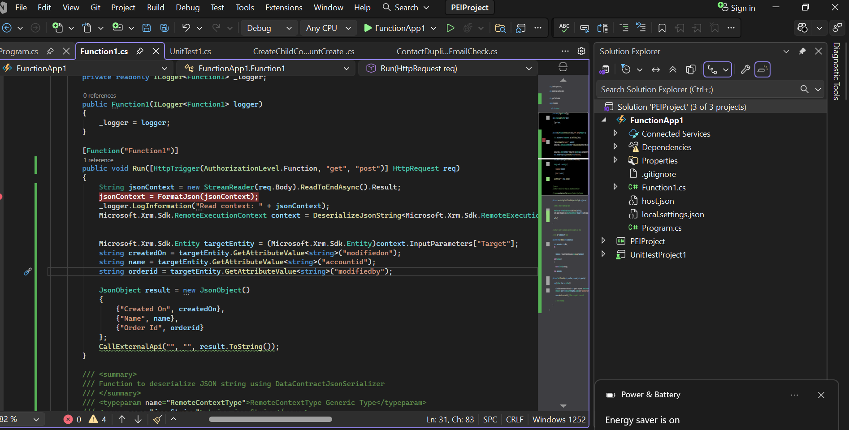

***Trigger:***

Register a webhook with plugin registration tool.

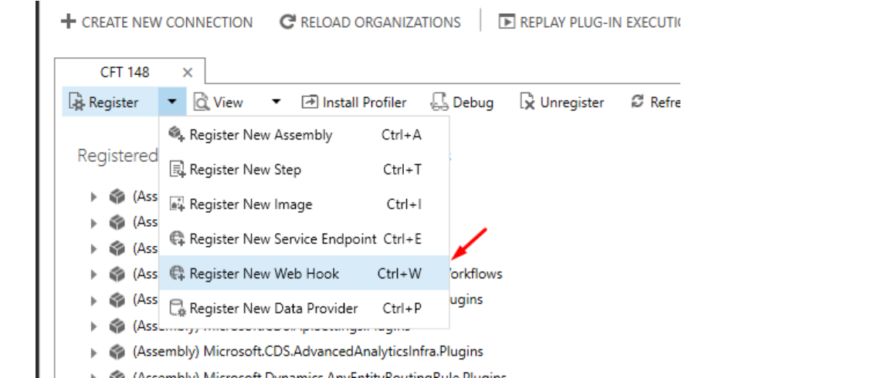

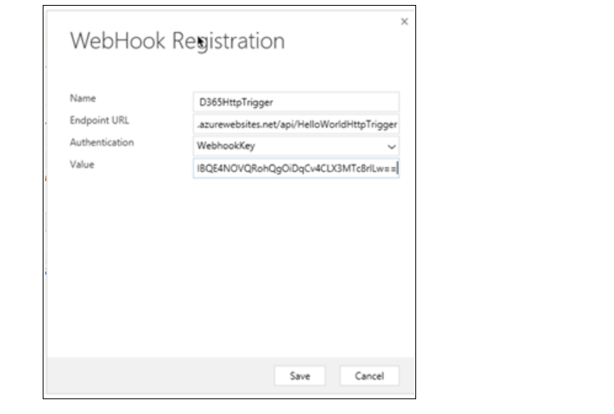

Register a new step for this webhook.

* **Message:** Create
* **Primary Entity:** Order
* **Event Pipeline Stage:** PostOperation
* **Execution Mode:** Asynchronous

**Security recommendation:**

Encrypt the data with symmetric key encryption if it contains sensitive information before sending to Api’s

Use OAuth 2.0 authentication while connecting the API’s instead of API key or basic authentication

**5. XRM Toolbox Task**

**Scenario**:

* Use XRM Toolbox for the following tasks:
  + **Bulk Update**: Update 50 Leads to set their Status to "Qualified."
  + **Metadata Report**: Generate a report for the Leads entity listing all attributes and their properties.

**Bulk Update:**

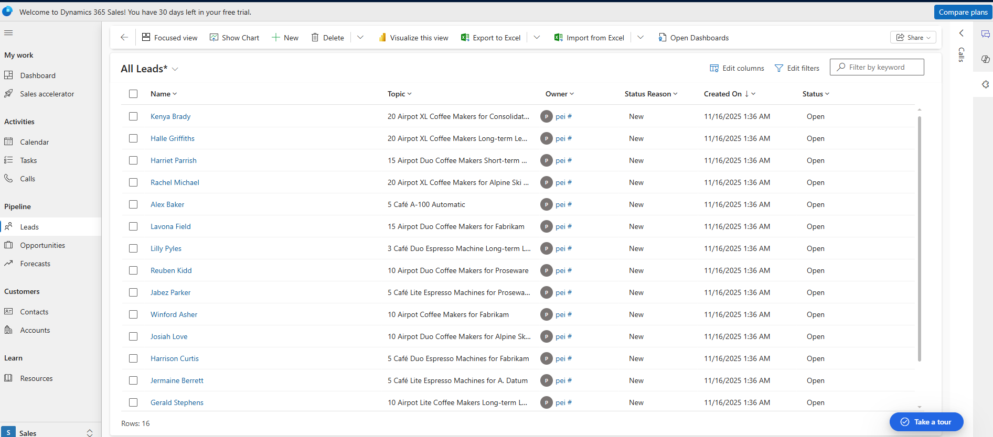

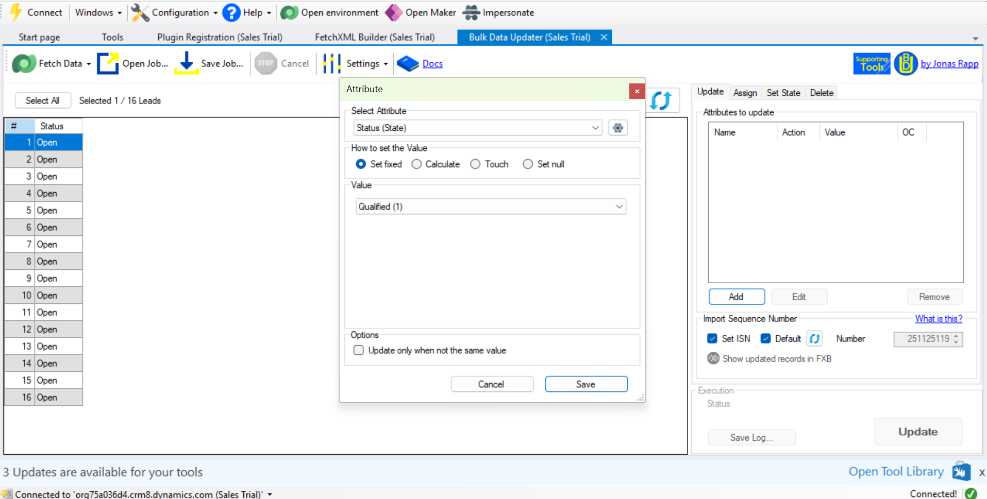

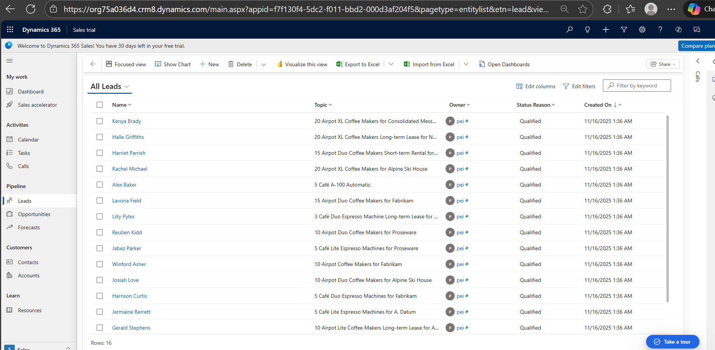

**Scenario 2(Attribute Export):**

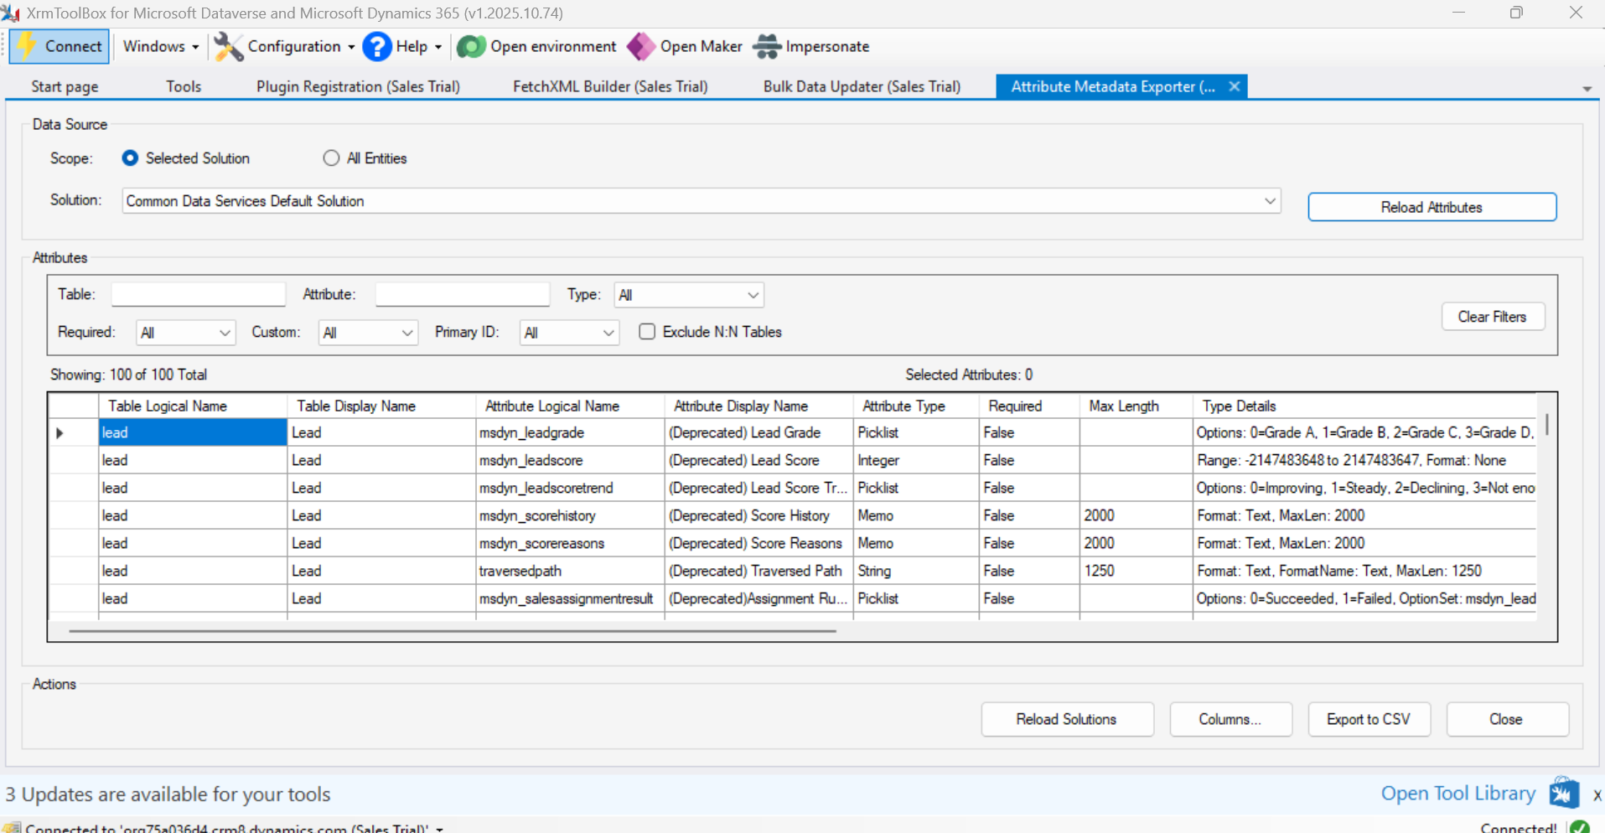

**Exported file is attached separately**